**THE PATTERNS COMPANY**

4th Floor, Bizness Square Junction Opposite Hitex Road, HITEC City, Madhapur, Hyderabad, Telangana 500084

+91-8500693113

+91-9392744210

[info@thepatternscompany.com](mailto:info@thepatternscompany.com)

https://[www.thepatternscompany.com](http://www.thepatternscompany.com/)



Website Report for [www.nhsggc.scot](http://www.nhsggc.scot/)

This report grades your website based on the strength of various SEO factors such as On Page Optimization, O Page Links, Social and more. The overall Grade is on a A+ to F- scale, with most major, industry leading websites in the A range. Improving your grade will generally make your website perform better for users and rank better in search engines. There are recommendations for improving your website at the bottom of the report. Feel free to reach out to us if you’d like us to help with improving your website’s SEO!

Audit Results for [www.nhsggc.scot](http://www.nhsggc.scot/)



**B**

# Your page could be better

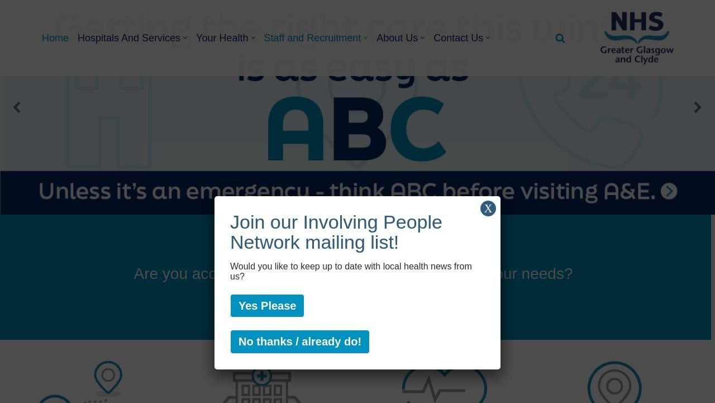

Recommendations: 15



**B**



**C+**



**B**



**A-**



**A-**

On-Page SEO

Links

Usability

Performance

Social

Recommendations

**Shorten meta description (to between 70 and 160 characters)**

On-Page SEO

Medium Priority

**Add H1 Header Tag**

On-Page SEO

Medium Priority

**Make greater use of header tags**

On-Page SEO

Medium Priority

**Update Link URLs to be more human and Search Engine readable**

Links

Low Priority

**Add Alt attributes to all images**

On-Page SEO

Low Priority

**Use your main keywords across the important HTML tags**

On-Page SEO

Low Priority

**Optimize your images to reduce their file size**

Performance

Low Priority

**Optimize your page for Mobile PageSpeed Insights**

Usability

Low Priority

**Optimize your page for Desktop PageSpeed Insights**

Usability

Low Priority

**Implement an analytics tracking tool**

On-Page SEO

Low Priority

**Create and link an associated LinkedIn profile**

Social

Low Priority

**Setup & Install a Facebook Pixel**

Social

Low Priority

**Remove inline styles**

Performance

Low Priority

**Add Local Business Schema**

Other

Low Priority

**Create Google Business Profile**

Other

Low Priority

On-Page SEO Results

**Your On-Page SEO could be better**

Your page has some level of On-Page SEO optimization but could be improved further. On-Page SEO is important to ensure Search Engines can understand your content appropriately and help it rank for relevant keywords. You should ensure that HTML Tag Content is completed correctly and align text content to target keywords.



**B**

## Title Tag

You have a title tag of optimal length (between 10 and 70 characters). Home - NHSGGC

Length : 13

## Meta Description Tag

Your page has a meta description tag however, your meta description should ideally be between 70 and 160 characters (including spaces).

NHS Greater Glasgow and Clyde provides and manages a wide range of health services including hospitals and General Practice with the Greater Glasgow and Clyde area.

Length : 164

A meta description is important for search engines to understand the content of your page, and is often shown as the description text blurb in search results.

## SERP Snippet Preview

This illustrates how your page may appear in Search Results. Note, this is intended as a guide and Search Engines are more frequently generating this content dynamically.

[https://www.nhsggc.scot](http://www.nhsggc.scot/)

Home - NHSGGC

NHS Greater Glasgow and Clyde provides and manages a wide range of health services including hospitals and General Practice with the Greater Glasgow ...

## Hreflang Usage

Your page is not making use of Hre ang attributes.

## Language

Your page is using the lang attribute. Declared: en-GB

## H1 Header Tag Usage

Your page does not have an H1 Header Tag.

The H1 Header Tag is an important way of signaling to search engines what your content is about, and subsequently the keywords it should rank for.

## H2-H6 Header Tag Usage

Your page is not making use of multiple levels of Header Tags.

HTML header tags are an important way of signaling to search engines the important content topics of your page, and subsequently the keywords it should rank for.

Header Tag Frequency

H3

1

H5

0

H6 0

H4 0

H2 0

## Keyword Consistency

Your page's main keywords are not distributed well across the important HTML tags.

Your page content should be focused around particular keywords you would like to rank for. Ideally these keywords should also be distributed across tags such as the title, meta and header tags.

Individual Keywords

Keyword Title Meta Description

Tag

Headings Tags Page Frequency

sta







56

care





✓

29

royal







28

glasgow



✓



27

from    28

thank    29

all    38

hospital    61

Phrases

Phrase Title Meta Description

Tag

Headings Tags Page Frequency

elizabeth university

hospital







9

royal hospital







13

all sta







10

royal alexandra

hospital







9

alexandra hospital







9

elizabeth university    9

queen elizabeth    10

hospital glasgow    15

## Amount of Content

Your page has a good level of textual content, which will assist in it's ranking potential. Word Count: 3149

## Image Alt Attributes

You have images on your page that are missing Alt attributes.

We found 34 images on your page and 4 of them are missing the attribute.

Alt attributes are an often overlooked and simple way to signal to Search Engines what an image is about, and help it rank in image search results.

## Canonical Tag

Your page is using the Canonical Tag.

https://[www.nhsggc.scot/](http://www.nhsggc.scot/)

## Noindex Tag Test

Your page is not using the Noindex Tag which prevents indexing.

## Noindex Header Test

Your page is not using the Noindex Header which prevents indexing.

## SSL Enabled

Your website has SSL enabled.

## HTTPS Redirect

Your page successfully redirects to a HTTPS (SSL secure) version.

## Robots.txt

Your website appears to have a robots.txt le.

<http://www.nhsggc.scot/robots.txt>

## Blocked by Robots.txt

Your page does not appear to be blocked by robots.txt.

## XML Sitemaps

Your website appears to have an XML sitemap.

https://[www.nhsggc.scot/sitemap_index.xml](http://www.nhsggc.scot/sitemap_index.xml)

## Analytics

We could not detect an analytics tool installed on your page.

Website analytics tools like Google Analytics assist you in measuring, analyzing and ultimately improving tra c to your page.

## Schema.org Structured Data

You are using JSON-LD Schema on your page.

Rankings

## Top Keyword Rankings

This shows your top 10 Keyword Rankings in the speci c location. The list is ordered by the keywords that drive the most tra c to your page.

Keyword Country & Language

Position Total Searches Estimated Tra c



glasgow queen elizabeth

hospital

EN

1

33,100

10,062

queen elizabeth glasgow  EN 1 33,100 10,062



queen elizabeth hospital

glasgow

EN

1

33,100

10,062

queen elizabeth hospital scotland

 EN 1 33,100 10,062



queen elizabeth

university glasgow

EN

1

33,100

10,062

queen elizabeth

university hospital

 EN 1 33,100 10,062



queen elizabeth

university hospital glasgow

EN

1

33,100

10,062

glasgow in rmary  EN 1 22,200 6,748



glasgow in rmary

hospital

EN

1

22,200

6,748

glasgow royal in rmary  EN 1 22,200 6,748

## Total Traffic From Search

This shows you the Estimated Tra c Volume your page receives from it’s Keyword Rankings



# 500,150

Monthly Tra c Volume

## Keyword Positions

This shows you a summary of the positions for your Keyword Rankings. The higher you rank, the more likely you are to capture tra c, with recent research showing that as much as 92% of clicks happen on the rst page.

Position Keywords

Position 2-3

619

Position 11-20

3,428

Position 31-100

28,109

Position 21-30 3,500

Position 4-10 2,146

Position 1 759

Links

## Backlink Summary

You have a strong level of backlink activity to this page.



**71**



**13**

Domain Strength

Page Strength



**961**

Referring Domains

**11.1k**

Backlinks

|  |  |  |  |  |  |
| --- | --- | --- | --- | --- | --- |
| **1.8k**  Nofollow Backlinks | **9.3k**  Dofollow Backlinks | **1**  Edu Backlinks | **125**  Gov Backlinks | **620**  Subnets | **792**  IPs |

## Top Backlinks

These are the highest value external pages we have found linking to your site.

Domain strength

Referring Page URL

100 https://en.wikipedia.org/wiki/List_of_public_inquiries_in_the_United_Kingdom

100 https://[www.microsoft.com/en-us/research/blog/3d-telemedicine-brings-better-care-to-underser](http://www.microsoft.com/en-us/research/blog/3d-telemedicine-brings-better-care-to-underser) ved-and-rural-communities-even-across-continents/

97 https://[www.gov.uk/guidance/cervical-screening-education-and-training](http://www.gov.uk/guidance/cervical-screening-education-and-training)

95 https://theconversation.com/drug-deaths-are-rising-and-overdose-prevention-centres-save-lives- so-why-is-the-uk-unwilling-to-introduce-them-192044

95

https://journals.sagepub.com/doi/10.1177/13623613231192870?icid=int.sj-full-text.citing-articles.4

72&

93 https://[www.newsweek.com/rankings/worlds-best-hospitals-2023/united-kingdom](http://www.newsweek.com/rankings/worlds-best-hospitals-2023/united-kingdom)

92 https://[www.buzzsprout.com/1835170/10147498](http://www.buzzsprout.com/1835170/10147498)

91 https://help nder.beateatingdisorders.org.uk/nhs-greater-glasgow-and-clyde-connect-ed-eating- disorders/

90 https://[www.gla.ac.uk/news/headline_863600_en.html](http://www.gla.ac.uk/news/headline_863600_en.html)

90 https://[www.mentalhealth.org.uk/our-work/programmes/adults/arts-scotland/scottish-mental-he](http://www.mentalhealth.org.uk/our-work/programmes/adults/arts-scotland/scottish-mental-he) alth-arts-festival-smhaf

## Top Pages by Backlinks

These are the pages on your site with the most the backlinks from other sites.

URL Backlinks

https://[www.nhsggc.scot/hospitals-services/services-a-to-z/musculoskel...](http://www.nhsggc.scot/hospitals-services/services-a-to-z/musculoskel)

597

https://[www.nhsggc.scot/](http://www.nhsggc.scot/)

213

https://[www.nhsggc.scot/hospitals-services/our-hospitals/glasgow-royal...](http://www.nhsggc.scot/hospitals-services/our-hospitals/glasgow-royal)

113

https://[www.nhsggc.scot/your-health/right-care-right-place/minor-injur...](http://www.nhsggc.scot/your-health/right-care-right-place/minor-injur)

104

https://[www.nhsggc.scot/your-health/heads-up-mental-health-support/](http://www.nhsggc.scot/your-health/heads-up-mental-health-support/)

90

https://[www.nhsggc.scot/hospitals-services/our-hospitals/queen-elizabe...](http://www.nhsggc.scot/hospitals-services/our-hospitals/queen-elizabe) 103

https://[www.nhsggc.scot/your-health/general-vaccinations/overseas-trav...](http://www.nhsggc.scot/your-health/general-vaccinations/overseas-trav) 113

https://[www.nhsggc.scot/your-health/right-care-right-place/](http://www.nhsggc.scot/your-health/right-care-right-place/) 145

https://[www.nhsggc.scot/your-health/general-vaccinations/overseas-trav...](http://www.nhsggc.scot/your-health/general-vaccinations/overseas-trav) 315

https://[www.nhsggc.scot/your-health/covid-19/](http://www.nhsggc.scot/your-health/covid-19/) 5,209

## Top Anchors by Backlinks

These are the top pieces of Anchor Text we found used to link to your site.

Anchor Backlinks

155

NHS Greater Glasgow and Clyde Travel advice, Vaccinations and Medication

124

[www.nhsggc.scot](http://www.nhsggc.scot/)

112

Travel vaccination details 84

Visit website 119

Right Care, Right Place - NHSGGC 136

Physio Self Referral Form 630

Coronavirus (COVID-19) Guidance 5,207

Go Now

652

Go Health

## Top Referring Domain Geographies

These are the Top Geographies we have found linking to your site.

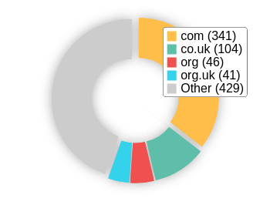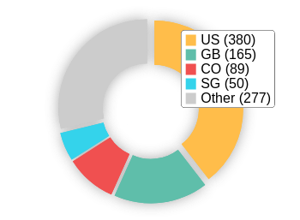Top TLDs Top Countries

## On-Page Link Structure

We found 395 total links. 3% of your links are external links and are sending authority to other sites. 1% of your links are nofollow links, meaning authority is not being passed to those destination pages.

## Friendly Links

Some of your link URLs do not appear friendly to humans or search engines.

We would recommend making URLs as readable as possible by reducing length, le names, code strings and special characters.

Usability

## Your usability could be better



**B**

Your page is OK but could be more usable across devices. Usability is important to maximize your available audience and minimize user bounce rates (which can indirectly a ect your search engine rankings).

## Device Rendering

This check visually demonstrates how your page renders on di erent devices. It is important that your page is optimized for mobile and tablet experiences as today the majority of web tra c comes from these sources.

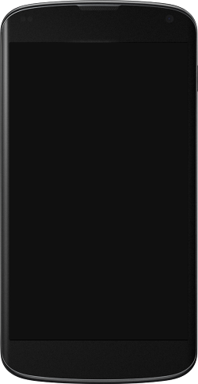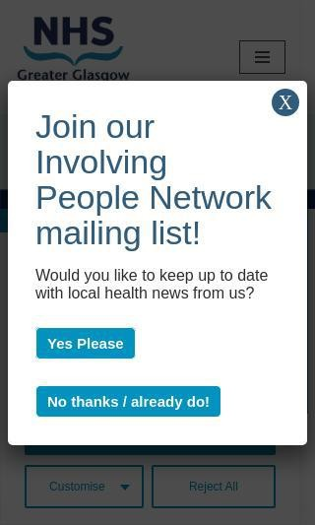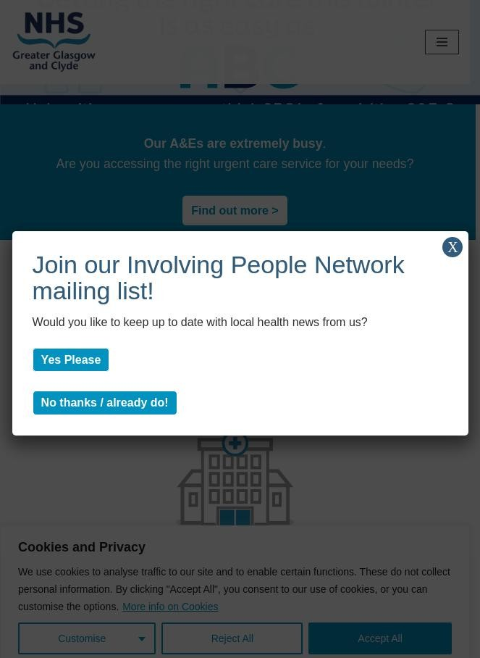

## Google's Core Web Vitals

Your page has passed Google's Core Web Vitals assessment.

Largest Contentful Paint (LCP)

First Input Delay (FID)

Cumulative Layout Shift (CLS)

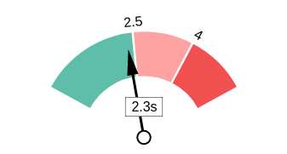 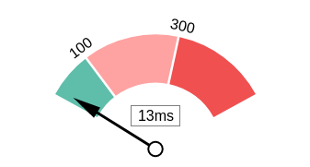 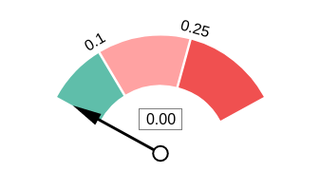

## Use of Mobile Viewports

Your page speci es a viewport matching the device's size, allowing it to render appropriately across devices.

## Google's PageSpeed Insights - Mobile

Google is indicating that your page is scoring poorly on their Mobile PageSpeed Insights evaluation.

Note that this evaluation is being performed from US servers and the results may di er slightly from an evaluation carried out from Google's PageSpeed Web Interface as that reporting localizes to the region in which you are running the report.

Google has indicated that the performance of a webpage is becoming more important from a user and subsequently ranking perspective.



**27**

Opportunities Estimated Savings

Eliminate render-blocking

resources

1.55 s

Properly size images

4.8 s

E ciently encode images

1.35 s

Avoid multiple page redirects

0.63 s

Minify CSS 0.15 s

Reduce unused CSS 0.75 s

Serve images in next-gen formats 5.85 s

|  |  |
| --- | --- |
| Lab Data | Value |
| First Contentful Paint | 4.1 s |
| Speed Index | 9.6 s |
| Largest Contentful Paint | 11.3 s |
| Time to Interactive | 11.3 s |
| Total Blocking Time | 1.07 s |
| Cumulative Layout Shift | 0 |

Preload Largest Contentful Paint image

0.15 s

## Google's PageSpeed Insights - Desktop

Google is indicating that your page is scoring poorly on their Desktop PageSpeed Insights evaluation.

Google has indicated that the performance of a webpage is becoming more important from a user and subsequently ranking perspective.



**58**

Lab Data Value

Speed Index

4.4 s

Time to Interactive

4 s

Total Blocking Time 0.02 s

Largest Contentful Paint 3.7 s

First Contentful Paint 2.6 s

Opportunities Estimated Savings

Serve images in next-gen

formats

1.06 s

Eliminate render-blocking resources

0.61 s

Cumulative Layout Shift 0.002

Reduce unused JavaScript

0.27 s

Minify CSS 0.27 s

E ciently encode images 0.27 s

Avoid multiple page redirects 0.19 s

|  |  |  |
| --- | --- | --- |
| **Flash Used?**  No Flash content has been identi ed on your page. |  | |
| **iFrames Used?**  There are no iFrames detected on your page. |  |  |
| **Favicon**  Your page has speci ed a favicon. |  |  |

## Email Privacy

No email addresses have been found in plain text on your page.

## Legible Font Sizes

The text on your page appears to be legible across devices.

## Tap Target Sizing

The links and buttons on your page appear to be appropriately sized for a user to easily tap on a touchscreen.

Performance Results

## Your performance is good

Your page has performed well in our testing meaning it should be reasonably responsive for your users, but there is still room for improvement. Performance is important to ensure a good user experience, and reduced bounce rates (which can also indirectly a ect your search engine rankings).



**A-**

## Page Speed Info

Your page loads in a reasonable amount of time.

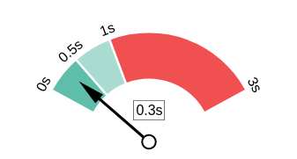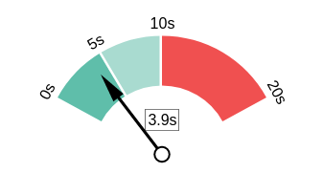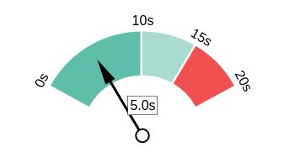Server Response All Page Content Loaded All Page Scripts Complete

## Download Page Size

Your page's le size is reasonably low which is good for Page Load Speed and user experience.

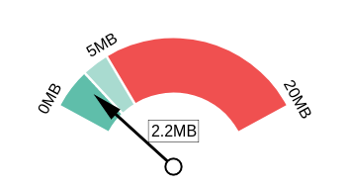Download Page Size Download Page Size Breakdown

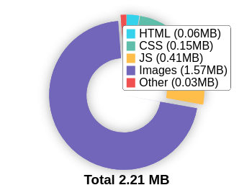

## Website Compression (Gzip, Deflate, Brotli)

Your website appears to be using a reasonable level of compression.

Compression Rates Raw Page Size Breakdown

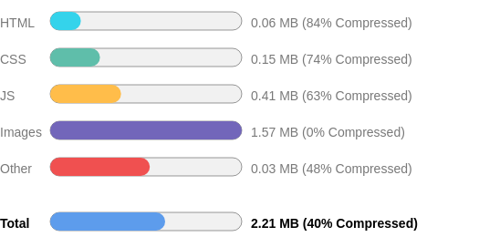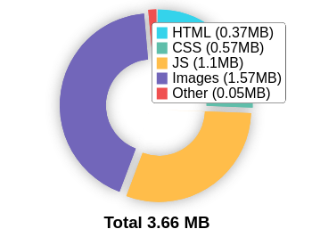

## Number of Resources

This check displays the total number of les that need to be retrieved from web servers to load your page.



# 73

Total Objects

**2**

Number of HTML Pages

**24**

Number of JS Resources

**17**

Number of CSS Resources

**22**

Number of Images

**8**

Other Resources

## Google Accelerated Mobile Pages (AMP)

This page does not appear to have AMP Enabled.

## JavaScript Errors

Your page is not reporting any JavaScript errors.

## HTTP2 Usage

Your website is using the recommended HTTP/2+ protocol.

## Optimize Images

Your page appears to include images which are poorly optimized.

Properly formatting and compressing images can have a signi cant impact on page load performance.

## Minification

All your JavaScript and CSS les appear to be mini ed.

## Deprecated HTML

No deprecated HTML tags have been found within your page.

## Inline Styles

Your page appears to be using inline styles.

Inline styles are an older coding practice and discouraged in favor of using CSS style sheets, due to their ability to degrade page load performance and unnecessarily complicate HTML Code.

Social Results

## Your social is good

You have a reasonably good social presence. Social activity is important for customer communication, brand awareness and as a marketing channel to bring more visitors to your website. We recommend that you have all of your pro les listed on your page, and work to build a larger following on those networks.



**A-**

## Facebook Connected

Your page has a link to a Facebook Page.

## Facebook Open Graph Tags

Your page is using Facebook Open Graph Tags.

## Facebook Pixel

We have not detected a Facebook Pixel on your page.

Facebook's Pixel is a useful piece of analytics code that allows you to retarget visitors if you decide to run Facebook Ads in future.

## Twitter Connected

Your page has a link to a Twitter pro le.

## Twitter Cards

Your page is using Twitter Cards.

## Instagram Connected

Your page has a link to an Instagram pro le.

## LinkedIn Connected

No associated LinkedIn pro le found linked on your page.

## YouTube Connected

Your page has a link to a YouTube channel.

## YouTube Activity

You have a good number of YouTube channel subscribers

 

# 13,700

Followers

# 5,260,595

View Count

Local SEO

## Local Business Schema

No Local Business Schema identi ed on the page.

## Google Business Profile Identified

No Google Business Pro le was identi ed that links to this website.

## Google Business Profile Completeness

No Google Business Pro le was identi ed that links to this website.

## Google Reviews

No Google Business Pro le was identi ed that links to this website.

Technology Results

## Technology List

These software or coding libraries have been identi ed on your page.

Technology Version



CookieYes

Google Analytics

hCaptcha

Font Awesome

Bootstrap

HSTS



jQuery Migrate

MySQL

PHP

Smart Slider 3

WordPress

Yoast SEO 22.0

W3 Total Cache

Popup Maker 1.18.2

Neve 3.8.1

Modernizr

jQuery

Yoast SEO Premium 22.0

## Server IP Address

20.0.114.104

**DNS Servers** anycast9.irondns.net anycast24.irondns.net

anycast10.irondns.net

anycast23.irondns.net

## Web Server

rocket

## Charset

text/html; charset=UTF-8



[https://www.thepatternscompany.com](https://www.thepatternscompany.com/)

**The Purpose of a Business is to create a Customer Who Creates Customer’s**

**Thank you**